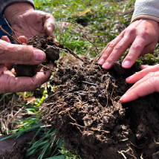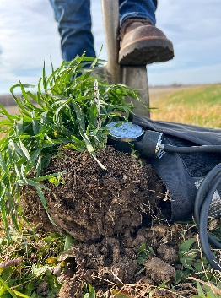

**SOUTHWEST IOWA**

**SUMMER FIELD DAY**

Join us for a day of crop, pasture,

and soil health information featuring

Iowa Farmers Ryan Gibbs and Jon Bakehouse!

**WHEN?**

Thursday, June 29th, 2023, 9:30 am – 2:30 pm, complimentary lunch included

**WHERE?**

Wallace Learning Center and Iowa State University Armstrong Research and Development Farm, 53020 Hitchcock Ave, Lewis Iowa 51544 (rain or shine)

|  |  |
| --- | --- |
| 9:30 | **Registration and slake tests at the Wallace Learning Center** |
|  | Visit sponsor tables |
|  |  |
| 10:00 | **Event welcome** |
|  |  |
| 10:20 | **Utilizing warm season annuals to boost pasture productivity** |
|  | Erika Lundy-Woolfolk and Aaron Saeugling, ISU Extension Specialists |
|  |  |
| 11:00 | **Commercially available nutrient enhancement products** |
|  | Brian Frishmeyer, Sound Farm Advice |
|  |  |
| **12:00 - 1:00 Complimentary lunch** | |
|  |  |
| 12:20 | **Soil biology and microscope introduction** |
|  |  |
| 12:30 | **Building plant health and nutrient availability with soil biology** |
|  | Ryan Gibbs, Delaware County Farmer and owner of Gibbsfield Ag, LLC |
|  |  |
| 1:35 | **Management of cover crops for weed control and soil health** |
|  | Jon Bakehouse, Mills County Farmer |
|  |  |
| 2:15 | Event wrap-up and ice cream social |

**SPONSORS**

**AGENDA?**

**EVALUATE YOUR SOIL!**

Interested in evaluating your soil stability? Bring a sample of your soil for a slake test. Collect a golf ball sized chunk of soil and let it air dry for at least 3 days before the event. Slake tests will be run during registration.

**Event is free and open to everyone. Pre-registration requested by June 23rd. Please register with Ruth Blomquist at 319-541-2969 (cell) or** [**ruth.blomquist@usda.gov**](mailto:ruth.blomquist@usda.gov)